Phone Book Management System

DOCUMENT CHANGE RECORD SHEET

Date | Versions | Description
10/08/2025 | 1.0 | Documentation Development
15/08/2025 | 1.0 | Đặt tả Functional Requirements and Non-Functional Requirements
19/08/2025 | 1.0 | Update Data Flow Diagram, Use case Diagram, Class Diagram, Data Model, Interface Design Description
21/08/2025 | 1.1 | Update Data Flow Diagram, Use case Diagram, Class Diagram, Data Model, Interface Design Description
22/08/2025 | 1.2 | Update Class Diagram, Data Model, Interface Design Description

- Phone Book Management System
The Phone Book online contact management system is built to support customers to manage, classify and retrieve contact information in the easiest, safest and most optimal way. The system includes the following detailed functions:
- Add and manage contacts:
  - Customers can select the function of adding a new contact and enter the details including: first and last name, primary phone number, email address, home address, and select the corresponding classification group. The system will check the data format (e.g. phone number in correct number format, correct email syntax) before storing it in the database. If the data is valid, the system saves a new record and displays a success message; If the data is invalid or missing the required fields, the system marks an error and asks the customer to re-enter it.
  - Customers can select a specific contact from the list to edit the information. The system displays a form containing the contact's current data for the customer to change the required fields. When the customer presses confirm the update, the system checks the validity of the new information and overwrites the data to the database, and at the same time gives a notification of the operation result.
  - Customers can choose to remove one or more contacts from their contacts. In order to avoid confusion, the system always displays a confirmation window (pop-up) asking customers if they are sure they want to delete it or not. If the customer agrees, the system will remove the record from the database and update the list again; If the customer cancels, then the deletion is stopped.
- View and search for contacts:
  - Customers can view a list of all contacts in their contacts as a list or pagination. The system automatically retrieves data from the database and displays full summary information including full name, phone number, group, and favorite flag. In case the contacts do not have data yet, the system will display the message "No contacts yet" to guide customers to create a new one.
  - Customers can search for quick contacts by entering keywords containing their full name, phone number, or email address in the search bar. The system scans the entire database and returns a list of matching results or containing the corresponding keyword. Customers can also incorporate filters such as grouping filtering or alphabetical (A-Z) sorting for easy lookup.
- Categorize groups and manage favorites:
  - Customers can manage contact groups by initializing new groups (enter group names and descriptions), editing group names, or deleting groups that no longer need to be used (e.g., Family, Colleagues, Customers). Customers can assign a contact to one or more groups at the same time to facilitate work and life management.
  - Customers can flag favorites for important contacts or frequently interact with them through the star icon right in the list. The system records the status and provides its own screen to help customers quickly filter and view a list of their favorite contacts.
- Account management and security:
  - The customer logs in to the system with a username and personal password. The system is responsible for checking and comparing credentials in the database before granting customers permission to access their own contact management page.
  - Customers can actively change their passwords by entering their current passwords and new passwords to ensure information security. In addition, customers can choose to log out to end the session, the system will delete the session information and return to the login screen.

- Glossary
- Contact: A contact's personal stored information, including their full name, phone number, email, address, and classification group.
- Group: A user-defined classification label for grouping contacts with the same attributes (such as Colleagues, Family, Friends).
- Favorite Contact: Priority flags help users quickly access important contacts.
- Account: User/Admin's identification information to log in and secure the personal data area.

- Supplementary Specification

Usability
The interface adjusts itself according to the device screen size (Responsive Design).

Reliability
The system must operate continuously 24/7 with reliability that reaches .$>99.9\%$

Performance
The system is capable of responding to 10,000 customers accessing simultaneously. Capable of storing customer information and orders/contact records.$500.000+1.000.000+$

Supportability
None

Security
Customers are only allowed to view and manage information and data under their own ownership. Avoid SQL Injection, XSS security errors. Use solutions to avoid automated software flooding data

Development requirement
Use the MySQL database management system. C++ Development Language. Server Centos 6.0.

- Data Flow
1. Overall Diagram
1.1. List of Components
External Entity
User: The person who uses the phone book management system.
Processes
- 1.0 Account Management – Manage user accounts.
- 2.0 Contact Management – Manage contacts.
- 3.0 Search for Contacts – Search for contacts.
- 4.0 Group Management – Manage contact groups.
- 5.0 Favorite Management – Manage favorite contacts.
Data Stores
- D1 – Account: Stores account information.
- D2 – Contact: Stores contact information.
- D3 – Group: Stores group information.
- D4 – Favorite: Stores information about favorite contacts.
Data Flows
The Main Data Flows Include
1. Account Management
- Registration information
- Registration result
- Login information
- Login result
- Updated account information
- Account information
-Update result
2. Contact Management
- New contact information
- Contact information
- Contact details
- Contact update information
- Delete contact request
- Contact list
- Add result
- Edit result
- Delete result
3. Search for Contacts
- Search criteria
- Search results
- Contact search results
4. Group Management
- New group information
- View group request
- Edit group request
- Delete group request
- Group information
- Group list
- Add group result
- Edit group result
- Delete group result
5. Favorite Management
- Contact to add
- View favorites request
- Favorite contact information
- Favorite contacts
- Add favorite result
- Contact to remove
- Remove favorite request
- Remove favorite information
- Remove favorite result
2. Data Flow 1: Account Management
2.1. Summary
The Account Management data flow is used to manage user account information, including account registration, login, and account information updates.
2.2. Components Involved
- External Entity: User
- Process: 1.0 Account Management
- Data Store: D1 – Account
- Data Flows:
  - Registration information
  - Registration result
  - Login information
  - Login result
  - Updated account information
  - Account information
  - Update result
2.3. Data Flow
Account Registration
User
↓ Registration information
1.1 Register Account
↓ New account information
D1 – Account
↓ Registration result
User
Account Login
User
↓ Login information
1.2 Login
↕
D1 – Account
↓ Account information
1.2 Login
↓ Login result
User
Account Update
User
↓ Updated account information
1.3 Update Account
↕
D1 – Account
↓ Account information
1.3 Update Account
↓ Update result
User
2.4. Input Data
The user provides:
- Registration information
- Login information
- Updated account information
Account information may include the username, password, and other necessary personal information.
2.5. Data Processing
The system:
- Receives the registration information.
- Validates the account information.
- Stores the account in D1 – Account.
- Verifies the login information against the stored account data.
- Allows the user to update account information.
- Updates the corresponding data in D1 – Account.
2.6. Output Data
The system returns:
- Registration result
- Login result
- Account information
- Update result
2.7. Conditions and Constraints
- Registration information must be complete.
- The account must not duplicate an existing account identifier.
- Login information must match the data stored in D1 – Account.
- Updated information must be valid before being stored.
3. Data Flow 2: Contact Management
3.1. Summary
The Contact Management data flow is used to manage contacts in the phone book, including adding, viewing, editing, and deleting contacts.
3.2. Components Involved
- External Entity: User
- Process: 2.0 Contact Management
- Data Store: D2 – Contact
- Data Flows:
  - New contact information
  - Contact information
  - Contact update information
  - Delete contact request
  - Contact list
  - Contact details
  - Add result
  - Edit result
  - Delete result
3.3. Data Flow
Add Contact
User
↓ New contact information
2.1 Add Contact
↓ New contact information
D2 – Contact
↓ Add result
User
View Contact
User
↓ View request
2.2 View Contact
↕
D2 – Contact
↓ Contact details
User
Edit Contact
User
↓ Contact update information
2.3 Edit Contact
↕
D2 – Contact
↓ Edit result
User
Delete Contact
User
↓ Delete contact request
2.4 Delete Contact
↓ Delete contact information
D2 – Contact
↓ Delete result
User
3.4. Input Data
- New contact information
- View request
- Contact update information
- Delete contact request
Contact information may include:
- Name
- Phone number
- Email
- Group
3.5. Data Processing
The system:
- Receives contact information.
- Validates the data.
- Stores the new contact in D2 – Contact.
- Retrieves contact information when the user requests to view it.
- Updates contact information when the user edits it.
- Deletes the contact when the user submits a delete request.
3.6. Output Data
- Contact list
- Contact details
- Add result
- Edit result
- Delete result
- Error message if the operation is invalid
3.7. Conditions and Constraints
- Contact information must be valid.
- Required information must not be missing.
- The contact must be identifiable before performing an Edit/Delete operation.
- Only authorized users can modify their contact data.
4. Data Flow 3: Search for Contacts
4.1. Summary
The Search for Contacts data flow allows users to search for contacts in the phone book based on criteria such as name, phone number, email, or group.
4.2. Components Involved
- External Entity: User
- Process: 3.0 Search for Contacts
- Data Store: D2 – Contact
- Data Flows:
  - Search criteria
  - Contact information
  - Search results
  - Contact search results
4.3. Data Flow
User
↓ Search criteria
3.1 Enter Search Criteria
↓ Search criteria
3.2 Search Contact
↕
D2 – Contact
↓ Search results
3.3 Display Search Results
↓ Contact search results
User
4.4. Input Data
The user enters:
- Name
- Phone number
- Email
- Group
These pieces of information are transmitted as Search criteria.
4.5. Data Processing
The system:
- Receives the search criteria.
- Identifies the information to be searched.
- Retrieves data from D2 – Contact.
- Compares contact data with the search criteria.
- Collects matching contacts.
- Displays the search results.
4.6. Output Data
- Search results
- Contact search results
If matching data is found, the system displays a list of suitable contacts.
4.7. Conditions and Constraints
- Search criteria must be valid.
- The user can search using one or multiple criteria.
- If no matching contact is found, the system returns an empty result or an appropriate notification.
5. Data Flow 4: Group Management
5.1. Summary
The Group Management data flow allows users to organize contacts into groups for easier management.
The operations include:
- Add group
- View group
- Edit group
- Delete group
5.2. Components Involved
- External Entity: User
- Process: 4.0 Group Management
- Data Store: D3 – Group
- Data Flows:
  - New group information
  - View group request
  - Edit group request
  - Delete group request
  - Group information
  - Group list
  - Add group result
  - Edit group result
  - Delete group result
5.3. Data Flow
Add Group
User
↓ New group information
4.1 Add Group
↓ New group information
D3 – Group
↓ Add group result
User
View Group
User
↓ View group request
4.2 View Group
↕
D3 – Group
↓ Group list
User
Edit Group
User
↓ Edit group request
4.3 Edit Group
↕
D3 – Group
↓ Edit group result
User
Delete Group
User
↓ Delete group request
4.4 Delete Group
↓ Delete group information
D3 – Group
↓ Delete group result
User
5.4. Input Data
- New group information
- View group request
- Edit group request
- Delete group request
5.5. Data Processing
The system:
- Receives group information from the User.
- Validates the group information.
- Stores the new group in D3 – Group.
- Retrieves the group list.
- Updates group information.
- Deletes the group according to the user's request.
5.6. Output Data
- Group information
- Group list
- Add group result
- Edit group result
- Delete group result
5.7. Conditions and Constraints
- The group name must be valid.
- Duplicate group names should not be allowed within the same account.
- The group must exist before performing an Edit/Delete operation.
- Only the User who owns the group is allowed to modify it.
6. Data Flow 5: Favorite Management
6.1. Summary
The Favorite Management data flow allows users to mark important contacts as favorites, view the favorite contacts list, and remove contacts from the favorites list.
6.2. Components Involved
- External Entity: User
- Process: 5.0 Favorite Management
- Data Store: D4 – Favorite
- Data Flows:
  - Contact to add
  - View favorites request
  - Contact to remove
  - Remove favorite request
  - Favorite contacts list
  - Add favorite result
  - Remove favorite result
6.3. Data Flow
Add Contact to Favorites
User
↓ Contact to add
5.1 Add Contact to Favorites
↓ Favorite contact information
D4 – Favorite
↓ Add favorite result
User

View Favorite Contacts
User
↓ View favorites request
5.2 View Favorites
↕
D4 – Favorite
↓ Favorite contacts
User
Remove Contact from Favorites
User
↓ Remove favorite request
5.3 Remove Contact from Favorites
↓ Remove favorite information
D4 – Favorite
↓ Remove favorite result
User
6.4. Input Data
- Contact to add
- View favorites request
- Contact to remove
- Remove favorite request
6.5. Data Processing
The system:
- Receives the contact that the User wants to add to favorites.
- Stores the favorite information in D4 – Favorite.
- Retrieves the favorite contacts list when requested by the User.
- Identifies the contact to be removed.
- Removes the contact from D4 – Favorite.
6.6. Output Data
- Favorite contacts list
- Add favorite result
- Remove favorite result
6.7. Conditions and Constraints
- The contact must exist before it can be added to favorites.
- A contact should not be added multiple times to the favorites list.
- The contact must exist in the favorites list before it can be removed.
- Only the User who owns the favorites list is allowed to modify it.

- Usse Case
1. Overview Diagram
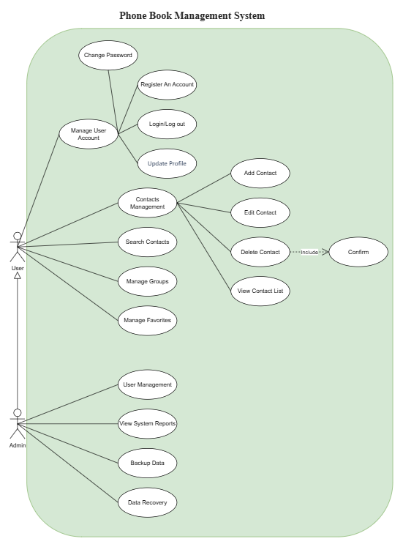

1.1. List of Actors
STT | Actor | Meaning
1 | User | Users use the system to manage personal accounts and contacts.
2 | Admin | System administrators, who have permission to manage users and view system reports.

1.2. List of Use Cases
STT | Use Case | Meaning
1 | Manage User Account | User Account Management
2 | Change Password | Change your password
3 | Register An Account | Register an account
4 | Login/Log out | Login/Logout
5 | Update Profile | Updating personal information
6 | Contacts Management | Manage your contacts
7 | Add Contact | Add a contact
8 | Edit Contact | Edit a contact
9 | Delete Contact | Delete a contact
10 | Confirm | Confirm the deletion operation
11 | View Contact List | View contact list
12 | Search Contacts | Search for contacts
13 | Manage Groups | Contact Group Management
14 | Manage Favorites | Manage Favorite Contacts
15 | User Management | User Management
16 | View System Reports | View system reports
17 | Backup Data | Back up your data
18 | Data Recovery | Data Recovery

1.3. Relationship between Use Cases
· Delete Contact <<include>> Confirm: when deleting a contact, the system is required to perform a confirmation step.
· The Admin inherits the User, so the Admin can use the User's functions and have additional administrative functions.

2. Use Case Manage User Account

2.1. Summary
This use case allows users to manage their personal accounts, including account registration, login/logout, password change, and update personal information.

2.2. Event Flow

2.2.1. Main event stream
The Use Case starts when the User selects the account management function.
1. The system displays the account management functions.
2. The user selects the function to be performed.
3. The system goes to the corresponding function.
4. The system performs and announces the results.

2.2.2. Other event lines
If the operation is invalid, the system will give an error message and ask the User to do it again.

2.3. Special requirements
Account information and passwords must be protected, not allowing users who do not have access to account data.

2.4. System Status Before Starting
None.

2.5. System status after implementation
Account information is updated according to the user's actions.

2.6. Extension Points
None.

3. Use Case Register An Account

3.1. Summary
This use case allows the user to register a new account on the system.

3.2. Event Flow

3.2.1. Main event stream
1. The user selects the account registration function.
2. The system displays the registration form.
3. The user enters the required information.
4. The system checks the validity of information.
5. The system creates a new account.
6. The system notifies you of successful registration.

3.2.2. Other event streams
If the information is invalid or the account already exists, the system gives an error message and asks to re-enter it.

3.3. Special requirements
Passwords must be protected and account information must be stored securely.

3.4. System Status Before Starting
The user does not have an account.

3.5. System status after implementation
If successful, a new account is created in the system.

3.6. Extension Points
None.

4. Use Case Login/Log out

4.1. Summary
This Use Case allows the User to log in to the system and log out of the system.

4.2. Event Flow

4.2.1. Main event stream
1. The user selects the login function.
2. The system requires credentials.
3. The user enters the account information and password.
4. Information Inspection System.
5. If the information is correct, the system allows the User to access.
6. When you choose to log out, the system ends the login session.

4.2.2. Other event streams
If the login information is incorrect, the system will give an error message and ask the User to re-enter it.

4.3. Special requirements
Credentials must be confidential.

4.4. System Status Before Starting
The user is not logged in.

4.5. System status after implementation
If the login is successful, the User is logged in. If logged out, the User returns to an unlogged-in state.

4.6. Extension Points
None.

5. Use Case Change Password

5.1. Summary
This use case allows the user to change the account password.

5.2. Event Flow
1. The user selects the Change Password function.
2. The system requires the entry of the current password and the new password.
3. User enters information.
4. Current password checking system.
5. The system checks the validity of the new password.
6. Password update system.
7. The system notifies the results.

5.3. Special Requirements
Passwords must be secure and meet the system's password policy.

5.4. System Status Before Starting
The user is logged in.

5.5. System status after implementation
A new password is saved in the system if the operation is successful.

5.6. Extension Points
None.

6. Use Case Update Profile

6.1. Summary
This use case allows users to update personal information.

6.2. Event Flow
1. User chọn Update Profile.
2. The system displays current personal information.
3. User editing information.
4. The user requests an update.
5. Validity checking system.
6. The system saves new information.
7. The system notifies the results.

6.3. Special requirements
Only the user who owns the account can update the information of that account.

6.4. System Status Before Starting
The user is logged in.

6.5. System status after implementation
Personal information is updated if the data is valid.

6.6. Extension Points
None.

7. Use Case Contacts Management

7.1. Summary
This use case allows users to manage contacts, including adding, editing, deleting, and viewing contact lists.

7.2. Event Flow
1. User chọn Contacts Management.
2. The system displays the contacts management functions.
3. The user selects the function to be performed.
4. The system performs the corresponding function.
5. The system notifies the results.

7.3. Special Requirements
Users are only allowed to manage contacts in their contacts.

7.4. System Status Before Starting
The user is logged in.

7.5. System status after implementation
Contacts are updated according to the user's actions.

7.6. Extension Points
None.

8. Use Case Add Contact

8.1. Summary
This use case allows the user to add a new contact to the contacts.

8.2. Event Flow
1. The user selects Add Contact.
2. The system displays a form to enter contact information.
3. User enters contact information.
4. Data Inspection System.
5. New contact saving system.
6. The system notifies the results.

8.3. Special Requirements
Contact information must be checked for validity before saving.

8.4. System Status Before Starting
The user is logged in.

8.5. System status after implementation
A new contact is added to the contacts.

8.6. Extension Points
None.

9. Use Case Edit Contact

9.1. Summary
This use case allows the user to edit the information of a contact that is already in the contacts.

9.2. Event Flow
1. The user selects Edit Contact.
2. The system displays contact information.
3. User editing information.
4. The user requests to save the changes.
5. Information Inspection System.
6. Contact update system.
7. The system notifies the results.

9.3. Special Requirements
Users can only edit contacts in their contacts.

9.4. System Status Before Starting
The contact that needs to be edited already exists.

9.5. System status after implementation
Contact information is updated.

9.6. Extension Points
None.

10. Use Case Delete Contact

10.1. Summary
This use case allows the User to delete a contact from the contacts.

10.2. Event Flow
1. The user selects the contact to delete.
2. User chọn Delete Contact.
3. The system requires confirmation.
4. Use Case Confirm is performed.
5. If the user confirms, the system deletes the contact.
6. The system notifies the results.

10.3. Special requirements
The system must require confirmation before deletion to avoid mistakenly deleting data.

10.4. System Status Before Starting
The contact to be deleted exists in the contacts.

10.5. System status after implementation
The contact is removed from the contacts if the User confirms.

10.6. Extension Points
Use Case Confirm is <<include>>.

11. Use Case Confirm

11.1. Summary
This use case allows the user to confirm the contact deletion operation.

11.2. Event Stream
1. The system displays a confirmation request.
2. The user chooses to confirm or cancel.
3. If confirmed, the system will continue the deletion operation.
4. If canceled, the system will end the operation and keep the data.

11.3. Special Requirements
None.

11.4. System Status Before Starting
The user is deleting a contact.

11.5. System status after implementation
The system performs or cancels the deletion operation according to the user's choice.

11.6. Extension Points
Be <<included>> by Use Case Delete Contact.

12. Use Case View Contact List

12.1. Summary
This use case allows the user to view a list of contacts in the contacts.

12.2. Event Stream
1. User chọn View Contact List.
2. Contact list retrieval system.
3. The system displays the contact list.
4. Users can select a contact to view the information.

12.3. Special Requirements
Show only contacts that belong to the User's account.

12.4. System Status Before Starting
The user is logged in.

12.5. System Status After Implementation
The contact list is displayed.

11.6. Extension Points
None.

13. Use Case Search Contacts

13.1. Summary
This Use Case allows the User to search for a contact in the contacts.

13.2. Event Flow
1. User chọn Search Contacts.
2. The system displays the search box.
3. User enters a keyword.
4. Contacts search system.
5. The system displays matching contacts.

13.3. Special Requirements
Search results are only taken from the user's contacts.

13.4. System Status Before Starting
The user is logged in.

13.5. System status after implementation
The contact list matches the keyword displayed.

13.6. Extension Points
None.

14. Use Case Manage Groups

14.1. Summary
This use case allows the User to manage contact groups in the contacts.

14.2. Event Flow
1. User chọn Manage Groups.
2. The system displays a list of groups.
3. The user selects the group to manage.
4. The user performs the group management operation.
5. The system updates group information.
6. The system notifies the results.

14.3. Special Requirements
Only the user who owns the contacts can manage their groups.

14.4. System Status Before Starting
The user is logged in.

14.5. System status after implementation
Group information is updated according to the user's actions.

14.6. Extension Points
None.

15. Use Case Manage Favorites

15.1. Summary
This use case allows users to manage a list of their favorite contacts.

15.2. Event Stream
1. User chọn Manage Favorites.
2. The system displays a list of favorite contacts.
3. The user selects the contact to manage.
4. The user performs the action of adding or removing from the wishlist.
5. The system updates the list.
6. The system notifies the results.

15.3. Special Requirements
The favorites list must belong to the current user.

15.4. System Status Before Starting
The user is logged in.

15.5. System status after implementation
The list of favorite contacts is updated.

15.6. Extension Points
None.

16. Use Case User Management

16.1. Summary
This use case allows the Admin to manage users in the system.

16.2. Event Stream
1. Admin chọn User Management.
2. The system displays a list of users.
3. The admin selects the users to manage.
4. The admin performs the management operation.
5. Permissions and data checking system.
6. Information update system.
7. The system notifies the results.

16.3. Special Requirements
Only Admins can perform user management functions.

16.4. System Status Before Starting
The admin is logged in and has administrative rights.

16.5. System status after implementation
User information is updated according to administrative actions.

16.6. Extension Points
None.

17. Use Case View System Reports

17.1. Summary
This Use Case allows Admins to view reports related to system activity.

17.2. Event Stream
1. Admin selects View System Reports.
2. Reporting data retrieval system.
3. Data aggregation system.
4. The system displays the report to the Admin.

17.3. Special Requirements
Reporting information is only available to Admins or people with administrative rights.

17.4. System Status Before Starting
The admin is logged in and has permission to view the report.

17.5. System status after implementation
The system report is displayed.

17.6. Extension Points
None.

18. Use Case Backup Data

18.1. Summary
This use case allows the backup system to perform a backup of the system's data to ensure that the data can be restored when necessary.

18.2. Event Stream
1. The backup system starts the backup process.
2. The system determines the data to be backed up.
3. The system creates a copy of the data.
4. The system saves the copy to the backup area.
5. The system notifies the backup results.

18.3. Special Requirements
Backup data must be protected and ensure integrity.

18.4. System Status Before Starting
System data exists and is accessible.

18.5. System status after implementation
A copy of the data is created successfully.

18.6. Extension Points
None.

19. Use Case Data Recovery

19.1. Summary
This use case allows the Backup system to restore system data from the backup when data is lost or needs to be recovered.

19.2. Event Stream
1. Backup system requires data recovery.
2. The system determines which backups to use.
3. The system checks the validity of the backup.
4. Data recovery system.
5. The system checks the recovery results.
6. The system notifies the results.

19.3. Special Requirements
The backup must be valid, and the data after recovery must ensure integrity.

19.4. System Status Before Starting
Have a valid backup of the system data.

19.5. System status after implementation
System data is restored to the state of the selected backup.

19.6. Extension Points
None.

- Class Diagram
- Class Diagram Overview
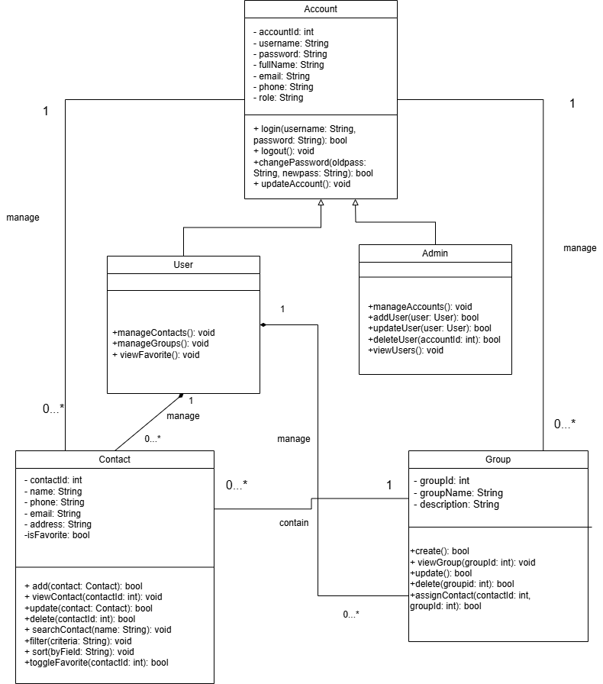
1.1. List of classes
Based on the Class Diagram, the current system consists of the following main classes:
- Account
- User
- Admin
- Contact
- Group
The general role of classes
- Account: The base layer stores account information and provides functions related to login, logout, and account updates.
- User: Inherited from Account, represents regular users and provides the functions of managing Contacts, Groups and viewing favorite Contacts.
- Admin: Inherited from the Account, represents the administrator and has the right to manage the User account.
- Contact: Saves a contact's information and provides the functions of adding, editing, deleting, searching, filtering, and sorting Contacts.
- Group: Saves group information and provides functions to create, edit, delete, view Groups, and assign contacts to Groups.
1.2. Relationships between classes
Class Diagram uses the following main types of relationships:
- Inheritance: Users and Admins inherit from Accounts.
- Association: Accounts that have a management relationship with Contacts and Groups; Contacts have a relationship with Groups.
- Composition: The User owns the Contact and Group by the Composition relationship, represented by a solid diamond on the User side.
2. Class Account
2.1. Class description
- Account is the base layer of the system, used to store the general information of an account.
- This layer provides basic account-related functions such as logging in, logging out, changing passwords, and updating account information.
- Account serves as the parent class for the User and Admin classes.
2.2. Properties
Attributes are set at the private level, represented by the - sign in the Class Diagram.

Attributes | Data types | Meaning
accountId | int | Account identifier
username | string | Username
password | string | Password
fullName | string | Full name
Email | string | Email Address
Phone | string | Phone Number
Role | string | The role of the account

2.3. Method

Method | Return Type | Meaning
login(username: String, password: String) | Anonymous | Check the information and perform the login
logout() | Void | Log out of your account
changePassword(oldpass: String, newpass: String) | Anonymous | Change your password
updateAccount() | Void | Account Updates

3. Class User
3.1. Class description
- User represents the regular user of the system.
- The User inherits from the Account, so the User can use the general information and functions of the account such as username, password, email, login and logout.
- In addition, users have additional functions to manage Contacts, manage Groups and view Contacts marked as favorites.
3.2. Properties
In the current Class Diagram, the User does not declare any additional attributes of their own.
The common attributes of the User are inherited from the Account class.
3.3. Method

Method | Return Type | Meaning
manageContacts() | Void | Manage your contact list
manageGroups() | Void | Manage Groups
viewFavorite() | Void | View Favorite Contacts

4. Class Admin
4.1. Class description
- Admin represents the administrator of the system. The Admin inherits from the Account, so the Admin also has the basic information and functions of an account.
- Unlike Users, Admins have the right to manage User accounts, including adding, updating, deleting, and viewing User lists.
4.2. Properties
In the current Class Diagram, the Admin does not have its own properties. Admins use attributes inherited from Accounts.
4.3. Method

Method | Return Type | Meaning
manageAccounts() | Void | Account Management
addUser(user: User) | Anonymous | Add a new user
updateUser(user: User) | Anonymous | Updating User Information
deleteUser(accountId: int) | Anonymous | Deleting a User Based on Account ID
viewUsers() | Void | View User List

5. Class Contact
5.1. Class Description
- A contact represents a contact that is stored in the system.
- This layer stores information such as contact codes, names, phone numbers, emails, addresses, and favorites.
- In addition to storing data, Contact also contains functions that handle contact lists such as adding, viewing, updating, deleting, searching, filtering, sorting, and marking favorites.
5.2. Properties

Attributes | Data types | Meaning
contactId | int | Mã Contact
name | string | The name of the contact
phone | string | Phone Number
email | string | Email Address
address | string | Address
isFavorite | bool | Determine whether a contact is popular or not

5.3. Method

Method | Return Type | Meaning
add(contact: Contact) | Anonymous | Thêm contact
view(contactId: int) | void | View Contact
update(contact: Contact) | bool | Contact Updates
delete(contactId: int) | bool | Xóa Contact
search(keyword: String) | Void | Search for contacts
filter(criteria: String) | Void | Filter contacts by condition
sort() | Void | Organize your contact list
toggleFavorite(contactId: int) | Anonymous | Change your favorite status

6. Class Group
6.1. Class description
- Group represents a Contact group.
- Each Group has a group ID, group name, and description. This class provides the functions of creating, viewing, updating, deleting Groups, and assigning contacts to Groups.
6.2. Properties

Attributes | Type of data | Meaning
groupId | int | Group Code
groupName | string | Team Name
description | string | Group Description

6.3. Method

Method | Return Type | Meaning
create() | Anonymous | Create a group
viewGroup(groupId: int) | Void | View Group List
update | Anonymous | Group Updates
delete(groupId: int) | Anonymous | Delete a Group
assignContact(contactId: int, groupId: int)  Anonymous | Anonymous | Assign a Contact to a Group

7. Describe relationships
7.1. Inheritance
The relationship of inheritance is expressed between:
- User → Account
- Admin → Account
Meaning:
The account contains the general characteristics of the account.
User and Admin are two different types of accounts that should be inherited from Accounts.
For example:
- The account has a username, password, email.
- The user reuses those attributes and adds the Contact/Group management function.
- Admin reuses those attributes and adds user management functionality.
Therefore, there is no need to re-declare the common attributes in User and Admin.
Here's the is-a relationship:
- User is an Account.
- Admin is an Account.
7.2. Association
Association is used to represent how the classes are related to each other.
Account – Contact
In the diagram, the Account is linked to the Contact with the manage label.
Multiplicity expressed:
Account 1 ───────── 0..* Contact
- An account can manage 0 or more Contacts.
- Each contact in this relationship is associated with 1 account.
It can be simply understood that an account can save and manage multiple contacts.
Account – Group
Similarly, the diagram shows:
Account 1 ───────── 0..* Group
- An account can manage 0 or more Groups.
- A Group belongs to an account in this relationship.
7.3. Composition
The composition relationship is represented by a rhombus with a color (◆). In the diagram, the User has a Composition relationship with the Contact and Group, with a solid diamond on the User's side.
User – Contact
User ◆──────── 0..* Contact
1
- A user can have multiple Contacts.
- A user may not have any contacts.
- Contact is a component that belongs to the user.
- When a User is deleted, the User's contacts are also considered deleted according to the User's lifecycle.
User – Group
Similar:
User ◆──────── 0..* Group
1
A user can have multiple groups. Groups are components that belong to the user and have a lifecycle that depends on the user.
8. Summarize relationships
Relations | Classes | Meaning
Inheritance | User – Account | User is a type of account
Inheritance | Admin – Account | Admin is a type of account
Association | Account – Contact | Account Manager Contact
Association | Account – Group | Account Management Group
Composition | User – Contact | User Owned 0..* Contact
Composition | User – Group | User owns 0..* Group
Association | Contact – Group | Groups containing Contacts

- Data Model
1. Overview Data Model Diagram
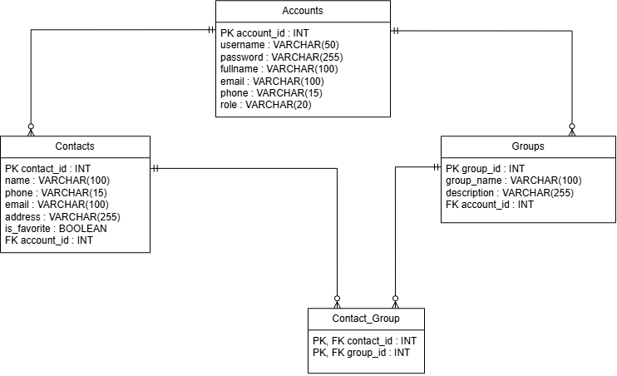
1.1. List of tables
The system consists of 04 main boards:
- Accounts: Stores user account information.
- Contacts: Stores a list of contact information.
- Groups: Stores a list of groups that categorize contacts.
- Contact_Group: The intermediate table that manages the link between contacts and groups.
1.2. Relationships between tables
Description of the relationship between tables:
• Accounts – Contacts: Relationship 1 – Many (1–N). An account owns multiple contacts.
• Accounts – Groups: Relationship 1 – Many (1–N). An account owns multiple groups.
• Contacts – Groups (via Contact_Group): Many-Many-Many(N–N) relationships. A contact can be in multiple groups, and a group contains multiple contacts.
1.3. Why design according to this model
Each Contact and Group is associated with a specific account (via account_id) to ensure privacy: users only see and operate on contacts and groups created by themselves, cannot access the data of other accounts. The N–N relationship between Contacts and Groups is separated into an intermediate table Contact_Group because a contact can belong to many different groups (for example, both the "Family" group and the "Coworkers" group), which a typical 1–N relationship does not represent.
2. Accounts table
2.1. Summary
The Accounts table is used to store login information, personal information and decentralize user accounts on the system.
2.2. Data Structure
2.2.1. Table structure
Column | Data Type | Constraint | Note
account_id | INT | PRIMARY KEY | Unique account identifier
username | VARCHAR(50) | NOT NULL, UNIQUE | Login username
password | VARCHAR(255) | NOT NULL | Hashed account password
fullname | VARCHAR(100) | NOT NULL | User's full name
email | VARCHAR(100) | UNIQUE | User's email
phone | VARCHAR(15) | NULL | User's phone number
role | VARCHAR(20) | NOT NULL, DEFAULT 'user' | Account role: user/admin

2.2.2. Detailed explanation of data fields
• account_id: A unique identifier for each account, which serves as the primary key for the system to distinguish and query quickly. The value is auto-increment, so users do not need to enter it, avoiding duplication.
• username: The username used for authentication. UNIQUE binding ensures that there are no two accounts with the same login name; NOT NULL because this is required to log in.
• password: Save encrypted passwords (hash), not plain text. The length of 255 characters is enough to contain common hash strings (bcrypt, SHA-256). Do not set UNIQUE because two users can accidentally match the same password without compromising business or security.
• fullname: Full name, used to display on the interface. Do not set UNIQUE as many users may have the same name.
• Email: Contacts, which can be used to recover passwords. Set UNIQUE so that each email is tied to only one account, avoiding conflicts when authenticating via email.
• phone: The contact phone number, which is not required to be entered because not all users provide it when registering.
• Role: Define the role (user/admin) for the system to decentralize access to the function. The default value 'user' ensures that the newly registered account does not inadvertently gain administrative rights.
2.3. Special requirements
• Two accounts with the same username or email are not allowed.
• Passwords are required to be encrypted before being saved to the database.
• Only Admins have the right to change the role field of another account.
2.4. System Status Before Starting
None. Accounts is the original table of the entire system, independent of data from any other table. The only condition is that the username and email (if any) declare do not exist in the system.
2.5. System status after implementation
A new Accounts record is created, or existing account information is updated. If an account is deleted, all Contacts and Groups belonging to that account are also deleted according to (ON DELETE CASCADE).
2.6. Extension Points
Fields such as avatar, created_at/updated_at, is_active (account activation status) can be added in the following versions.
3. Contacts Panel
3.1. Summary
The Contacts panel is used to store the details of each contact in the user's personal contacts.
3.2. Data Structure
3.2.1. Table structure
Column | Data Type | Constraint | Note
contact_id | INT | PRIMARY KEY | Unique contact identifier
name | VARCHAR(100) | NOT NULL | Contact name
phone | VARCHAR(15) | NOT NULL | Contact phone number
email | VARCHAR(100) | NULL | Contact email
address | VARCHAR(255) | NULL | Contact address
is_favorite | BOOLEAN | NOT NULL (Default: FALSE) | Favorite status
account_id | INT | NOT NULL, FOREIGN KEY REFERENCES Accounts(account_id) | Owner account

3.2.2. Detailed explanation of data fields
• contact_id: A unique identifier for each contact, which serves as the primary key.
• name: The name of the contact. Entry is required because this is the minimum information to identify a contact in the contacts.
• phone: The phone number of the contact. Import is required as this is the main purpose of the contacts manager app.
• Email: The contact's email, which is not required because not all contacts have this information available.
• address: The address of the contact, optional, saved only when the user provides more.
• is_favorite: Mark the contact as pinned to the favorites list or not. The default is FALSE when creating a new one, the user actively pops it up later.
• account_id: The foreign key refers to the Accounts.account_id, which account this contact belongs to. It is mandatory to NOT NULL because every contact must be tied to an account, ensuring data privacy between users.
3.3. Special requirements
• A contact belongs to only one account, not shared between different accounts.
• Users are only allowed to view, edit, and delete contacts of their own account.
3.4. System Status Before Starting
The account that owns the contact must already exist in the system before a contact record is created.
3.5. System status after implementation
A new contact is added to the account's contacts, or an existing contact is updated/deleted. If the contact is deleted, the corresponding link records in the Contact_Group are also deleted according to (ON DELETE CASCADE).
3.6. Extension Points
Fields such as avatar, birthday, and note can be added in later versions.
4. Groups Boards
4.1. Summary
Groups panels are used to store information about groups that categorize contacts set up by users.
4.2. Data Structure
4.2.1. Table structure
Column | Data Type | Constraint | Note
group_id | INT | PRIMARY KEY | Unique group identifier
group_name | VARCHAR(100) | NOT NULL | Group name
description | VARCHAR(255) | NULL | Group description
account_id | INT | NOT NULL, FOREIGN KEY REFERENCES Accounts(account_id) | Owner account

4.2.2. Detailed explanation of data fields
• group_id: A unique identifier for each group, which serves as the primary key.
• group_name: The name of the group (e.g., Family, Coworkers). Entry is required to differentiate groups from each other.
• description: Further description of the purpose or content of the group, optional.
• account_id: The foreign key references Accounts.account_id, which identifies which account created this group. NOT NULL is required because each group must always belong to a specific account.
4.3. Special requirements
• A group belongs to only one account.
• Users are only allowed to create, edit, and delete groups belonging to their own account.
4.4. System Status Before Starting
The account that owns the group must already exist in the system before a Group record is created.
4.5. System status after implementation
A new group is added to the system, or an existing group is updated/deleted. If the group is deleted, the corresponding link records in the Contact_Group are also deleted according to (ON DELETE CASCADE).
4.6. Extension Points
None.
5. Table Contact_Group (Intermediate Table)
5.1. Summary
The Contact_Group table serves as an intermediate table that connects Contacts and Groups, serving to assign a contact to one or more different groups.
5.2. Data Structure
5.2.1. Table structure
Column | Data Type | Constraint | Note
contact_id | INT | PRIMARY KEY, FOREIGN KEY REFERENCES Contacts(contact_id) | Contact reference
group_id | INT | PRIMARY KEY, FOREIGN KEY REFERENCES Groups(group_id) | Group reference

5.2.2. Detailed explanation of data fields
• contact_id: The foreign key references Contacts.contact_id, which determines which contacts are assigned to the group.
• group_id: The foreign key references Groups.group_id, which determines which group the contact is assigned to.
The contact_id and group_id columns together form the composite primary key of the table. This design ensures that each pair (contact_id, group_id) exists only once—that is, a contact cannot be duplicated in the same group multiple times.
5.3. Special Requirements
• A contact can appear in many different Contact_Group records (belonging to multiple groups).
• A group can appear in many different Contact_Group records (containing multiple contacts).
5.4. System Status Before Starting
Both the Contact and the linked Group must already exist in the system before a Contact_Group record is created.
5.5. System status after implementation
A new link between the Contact and the Group is established (or removed upon deletion). This doesn't change the original data in Contacts or Groups. When a Contact or Group is deleted, the corresponding link records in the Contact_Group are also deleted according to (ON DELETE CASCADE).
5.6. Extension Points
None.
6. Describe relationships
6.1. Accounts – Contacts
• An account can have multiple Contacts.
• Each contact belongs to an account.
• Contacts.account_id is the FK reference Accounts.account_id.
6.2. Accounts – Groups
• One account can create and own multiple Groups.
• Each Group belongs to a unique account.
• Groups.account_id is a Foreign Key (FK) that refers to Accounts.account_id.
6.3. Groups – Contact_Group
• A group can be associated with multiple records in a Contact_Group (which corresponds to how a group can contain multiple contacts inside).
• Each record in the Contact_Group refers to only one Group.
• Contact_Group.group_id is the Foreign Key (FK) that references the Groups.group_id.
6.4. Contacts – Contact_Group
• A contact can be associated with multiple records in a Contact_Group (which corresponds to a contact being able to be categorized into different groups).
• Each record in the Contact_Group refers to only one Contact.
• Contact_Group.contact_id is the Foreign Key (FK) that references the Contacts.contact_id.

- Interface Design Description

1. Interface overview
1.1. Interface Type
Describe the system using the console interface, and the user interacts through the menu, keyboard, and system notifications.
1.2. Interface design principles
Briefly describe the principles used by the group, for example:
- The menu is clear and easy to understand.
- Grouped functions.
- There is a notification when the operation is successful/failed.
- When invalid data is entered, the system asks the user to re-enter it.
2. Register Account Interface
2.1. Interface description
- The Register An Account interface is for users who do not have an account and want to register to use the system. The interface is designed to be simple, focusing on entering account information and creating new accounts.
- This interface is only for new users who have not logged in to the system. After successful registration, users can switch to the Login interface to log in.
2.2. Interface Components
- Username: enter the username.
- Password: the box to enter the password.
- Full Name: enter the first and last name.
- Email: enter the email address box.
- Phone: enter the phone number.
- Register: the button to confirm the registration.
- Login: the button/text switches to the login interface if the user already has an account.
- Error message: displayed when the data is invalid or the username already exists.
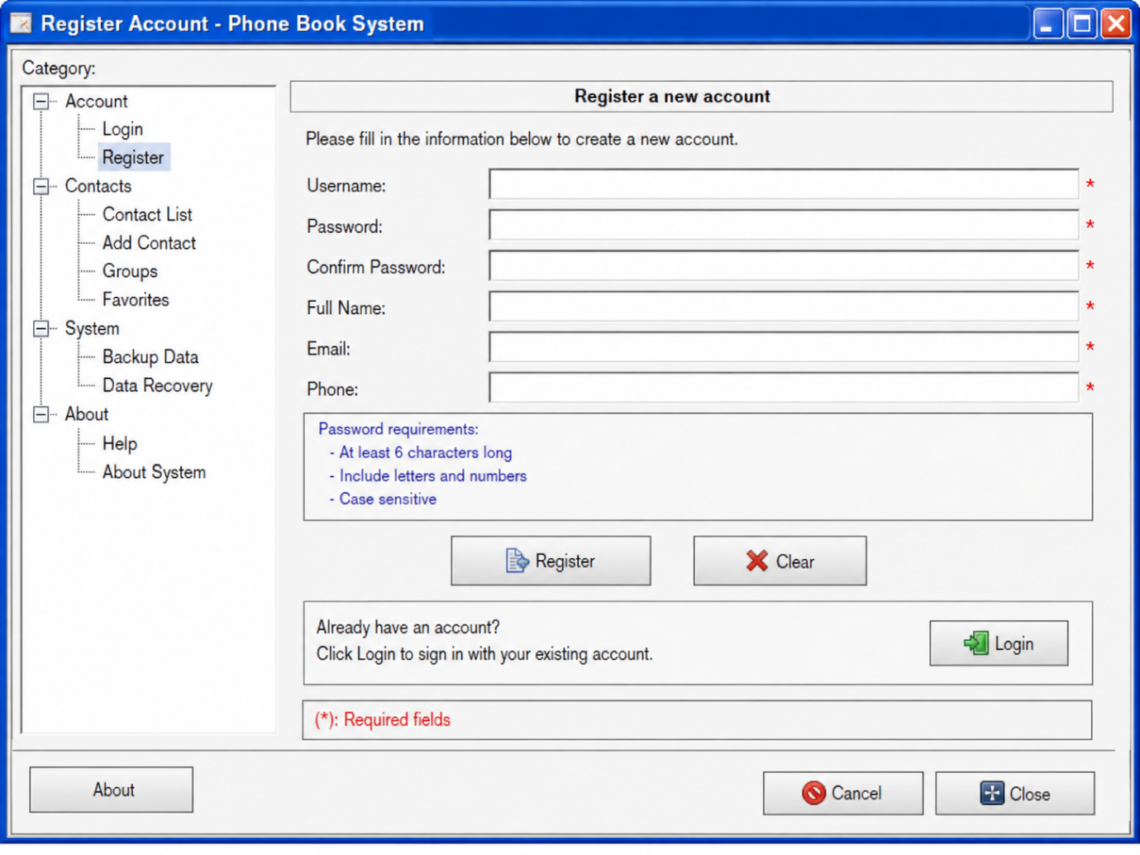
2.3. Interactive Flow
- The user enters all the information in the corresponding boxes and clicks Register. Data Inspection System.
- If the information is valid and the Username does not exist, the system creates a new account in the accounts table and notifies you of successful registration.
- If the information is invalid or the Username already exists, the system displays an error message and asks the user to re-enter it.
- If the user already has an account, select Login to switch to the login interface.
3. Login/Logout Interface
3.1. Interface Description
- The Login interface is for both Users and Admins to access the system. This is the first interface users use after starting the system.
- The interface allows users to enter account information for the system to authenticate and determine access permissions.
3.2. Interface Components
Username: Enter the username.
Password : the box to enter the password.
Login: login button.
Forgot Password: the function of regenerating passwords when the password is forgotten.
Register: switch to the account registration interface.
Change Password: allows logged-in users to change their passwords.
Logout: the button that ends the login session.
3.3. Interactive Flow
- Users enter Username and Password, then click Login.
- The system checks the information with the data in the accounts table. If the information is correct, the system determines the role value.
- If role = User, the system goes to the user interface.
- If role = Admin, the system goes to the Admin interface.
- If the login information is incorrect, the system displays an error message.
- When the user selects Logout, the system ends the session and returns the user to the Login interface.
4. Contact Management Interface
4.1. Interface description
- Contacts Management is a central interface for users to manage personal contacts. The interface displays the Contacts of the current account and provides actions to add, edit, delete, and view Contacts.
- The interface only displays data belonging to the User who is logged in based on the account_id.
4.2. Interface components
- Contact List: displays the Contacts.
- + sign: open the Add Contact interface.
- ...mark: opens actions for Contact, such as Edit or Delete.
- Magnifying glass icon: switch to Search Contacts.
- Favorites : go to or interact with Favorite.
- Title bar: displays the current function name.
- Contact information may include:
+ Name
+ Phone
+ Email
+ Address
+ Group
+ Favorite
4.3. Interaction Flow
The user logs in and selects Contacts Management.
The system retrieves the contacts with the account_id corresponding to the logged-in account and displays a list.
- Press + → open Add Contact.
- Press ...→ displays the Edit/Delete operation.
- Select Contact → view the Contact information.
- Select the search icon → switch to Search Contacts.
5. Add Contact Interface
5.1. Interface Description
The Add Contact interface allows users to create a new contact and save it to their contacts.
5.2. Interface Components
- Name: enter the name of Contact.
- Phone: enter your phone number.
- Email: enter your email.
- Address: enter the address.
- Group: select the group.
- Favorite: mark Favorite Contacts if needed.
- Save: lưu Contact.
- Cancel: cancel the operation.
- The Save button is the button that confirms the main operation, while the Cancel button is used to go back without saving the data.

5.3. Interaction Flow
- User press the + sign in Contacts Management.
- Add Contact opening system. User enters the information and clicks Save.
- Data Inspection System. If valid, the Contact is created and tied to the user's account_id.
- If the data is invalid, the system displays an error in the corresponding field.
- If you select Cancel, the system returns to Contacts Management and does not create a Contact.
6. Edit Contact Interface
6.1. Interface description
- The Edit Contact interface allows users to edit existing contact information.
6.2. Interface Components
- Name
- Phone
- Email
- Address
- Group
- Favorite
- Update: save new information.
- Cancel: unedit.
6.3. Interactive Flow
- User selects ... or the Edit icon next to Contact.
- The system opens the Edit Contact interface and displays the current data.
- The user changes the information and then clicks Update.
- The system checks the data and updates the corresponding records in the contacts table.
- If the User clicks Cancel, the system does not change the data.
7. Delete Contact Interface
7.1. Interface description
- The Delete Contact interface is used when a user wants to delete a contact from a contact.
- Because the deletion operation may result in data loss, the system must display a confirmation dialog box before performing it.
7.2. Interface Components
The interface/dialog includes:
- The contact name to be deleted.
- Confirmation content:
“Are you sure you want to delete this contact?”
- Confirm/Delete: confirm the deletion.
- Cancel: cancel the operation.
- The Confirm/Delete button should be prominently designed to show that this is an important operation; Cancel is used to close the dialog box.
7.3. Interactive Flow
User selects ... → Delete.
The system displays a confirmation dialog.
- Select Confirm → the system deletes the Contact.
- Select Cancel → close the dialog box and keep the Contact.
After successful deletion, the contact list is updated and the system displays a result message.
8. View Contact List Interface
8.1. Interface description
The View Contact List interface allows users to view all saved contacts in the account.
8.2. Interface components
- List of Contacts.
- Tên Contact.
- Phone number.
- Other basic information.
- Pen/Edit icon: edit Contact.
- Icon or mark...: opens more actions.
- Search bar: supports finding Contacts.
- Sorting options if the system supports.
8.3. Interactive Flow
The user opens the Contacts list.
The system retrieves data from the contacts table based on the user's account_id.
Users can:
- Select Contact → view details.
- Select the pen icon → open Edit Contact.
- Select ... → perform another operation.
- Use Search to find Contacts.
9. Search Contact Interface
9.1. Interface description
The Search Contact interface allows users to quickly find contacts in the contacts instead of having to view the entire list.
9.2. Interface Components
- Search Box: keyword input box.
- Magnifying glass icon: perform a search.
- Filter: filter the results if needed.
- Sort: sort the results.
- Search Result: the area where the results are displayed.
9.3. Interactive Flow
- The user enters keywords such as name, phone number, or email into the Search Box.
- User clicks the magnifying glass/Search icon.
- The system searches in the Contacts of the current account_id and displays the results.
- If there are no results, the system notifies you that no matching contact has been found.
10. Group Management Interface
10.1. Interface description
The Group Management interface allows users to categorize contacts into groups for convenient management.
10.2. Interface components
- Group List.
- +: create a new group.
- ...mark: open the Edit/Delete Group operation.
- Group Name: the name of the group.
- Description: a description of the group if applicable.
- List of contacts belonging to the Group.
10.3. Interactive Flow
- User mở Group Management.
- To create a new group, the User presses +, enters the Group name, and then selects Save.
- To edit or delete a Group, User selects ... next to the corresponding Group.
- Users can also select Contact and assign Contacts to Groups via group_id.
11. Favorite Management Interface
11.1. Interface Description
The Favorite Management interface allows users to manage important contacts that are marked as favorites.
11.2. Interface Components
-Favorite contact list.
-Heart icon: represents the Favorite status.
- Trash can icon: remove the contact from the Favorites list.
- Contact information such as Name and Phone.
11.3. Interactive Flow
-User selects the Contact's heart icon to mark as a favorite.
-The system updates the isFavorite attribute = true.
- When the User selects the trash can icon, the system unchecks the favorite by updating isFavorite = false.
-The Favorites list is updated again without the need to create a separate Favorites table.
12. User Account Management Interface
12.1. Interface Description
- The User Account Management interface allows Admins to manage User accounts in the system.
- This is an Admin-specific interface, not displaying the account management function for regular users.
12.2. Interface Components
- Account List.
- Account ID.
- Username.
- Full Name.
- Email.
- Phone.
- Role.
- + sign: add a new user.
- ...mark: opens an action for a User, such as Edit or Delete.
- Search: search for accounts.
- Mark... next to each User is used to open the editing or deletion operations of the User.
12.3. Interactive Flow
- Admin mở User Account Management.
- Account permission checking system.
- Admins can:
- Press + → to open the Add User interface.
- Press ... → edit or delete a user.
- Use Search → find accounts.
- View the user's information and role.
- In addition to checking permissions on the interface, the backend still has to check the role = Admin before allowing the implementation of administrative APIs to prevent unauthorized user access.
13. View System Reports Interface
13.1. Interface Description
The View System Reports interface allows Admins to track aggregate information of the system.
13.2. Interface Components
- Total Number of Users
- Total number of contacts
- Total Group
- Other statistical information
- Statistics table
- Figures can be presented with statistics cells or tables for Admins to easily observe.
13.3. Interactive Flow
-Admin select View System Reports.
-The system retrieves data and calculates the necessary figures.
-Results are displayed on the screen in the form of tables or statistical areas.
-Admin can view the metrics to track the operating status of the system.
14. Backup Data Interface
14.1. Interface description
The Backup Data interface allows Admins to create a backup of the system's data to protect data and serve for restoration when necessary.
14.2. Interface components
- Create Backup: starts the backup process.
- Backup History: a list of backups.
- Name of the backup file.
- Creation time.
- File size.
- Download: download the backup to the device.
- Status notification area.
14.3. Interactive Flow
Admin opens Backup Data and clicks Create Backup.
The system backs up the necessary data, such as:
- accounts
- contacts
- Groups
Upon completion:
“Backup completed successfully.”
are displayed.
If an error occurs, the system displays an error message and does not change the current data.
Admins can select Download to get the backup file to the device.
15. Data Recovery Interface
15.1. Interface Description
The Data Recovery interface allows the Admin to restore system data from a previously created backup file.
15.2. Interface components
- Choose File: chọn file backup.
- The area displays the selected file name.
- Restore: starts the restore.
- Cancel: cancel the operation.
- Confirm dialog before restoration.
- Result notification area.
15.3. Interaction Flow
Admin click Choose File and select the backup file from the device.
System Inspection File:
- If the file is valid → allow the Restore to be performed.
- If the file is invalid, → display an error message and do not recover.
Admin click Restore.
Display System:
“Are you sure you want to restore the data?”
If the Admin selects Confirm, the system proceeds to restore the data.
If Cancel is selected, the restore is canceled and the current data is preserved.
After success, the system displays:
“Data recovery completed successfully.”

